**Course Methods Test 1 Year 12**

Student name: ________________ Teacher name: ________________

**Task type: Response**

**Reading time for this test : 5 mins**

**Working time allowed for this task: 40 mins**

**Number of questions: _____6______**

**Materials required:** No Cals allowed at all!

Standard items: Pens (blue/black preferred), pencils (including coloured), sharpener, correction fluid/tape, eraser, ruler, highlighters

Special items: Drawing instruments, templates, notes on one unfolded sheet of   
A4 paper,

**Marks available: 34 marks**

**Task weighting: 13%**

**Formula sheet provided: no but formulae listed on next page.**

**Note: All part questions worth more than 2 marks require working to obtain full marks.**

Useful formulae

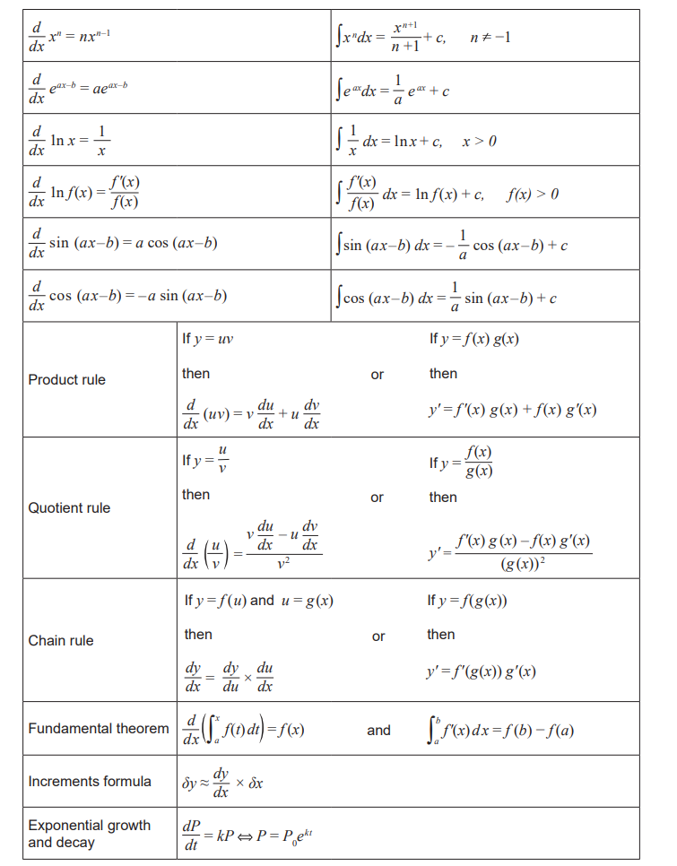

**No calculators allowed!!!**

Q1 (2, 2 & 2 = 6 marks)

Determine the gradient function for each of the following.

1. 

|  |
| --- |
| **c** |
|  |
| **Specific behaviours** |
| 🗸 diffs first term  🗸 diffs second term |

1. 

|  |
| --- |
| **c** |
|  |
| **Specific behaviours** |
| 🗸 rearranges y or uses quotient rule  🗸 states derivative |

1. 

|  |
| --- |
| **c** |
|  |
| **Specific behaviours** |
| 🗸 uses product rule  🗸 diffs all terms correctly (no need to simplify) |

Q2 (4 marks)

Determine the equation of the tangent to the curve at the point .

|  |
| --- |
| **c** |
|  |
| **Specific behaviours** |
| 🗸 uses quotient rule  🗸 determines gradient at x=1  🗸 solves for constant of tangent equation  🗸 states equation |

Q3 (2, 2, 2 & 4= 10 marks)

The table below contains the values of the polynomial function  and its first and second derivatives for .

There are no stationary points for non-integer values of .

|  |  |  |  |  |  |  |  |
| --- | --- | --- | --- | --- | --- | --- | --- |
|  | 0 | 1 | 2 | 3 | 4 | 5 | 6 |
|  | 12 | 5 | -2 | -13 | -20 | -35 | -5 |
|  | -4 | -12 | -5 | 0 | -11 | 0 | 15 |
|  | -8 | 0 | 2 | 0 | -5 | 7 | 10 |

1. Evaluate  when 

|  |
| --- |
| **c** |
|  |
| **Specific behaviours** |
| 🗸 uses chain rule  🗸 subs correct values  Note: no follow through if chain not used |

1. Evaluate  when 

|  |
| --- |
| **c** |
|  |
| **Specific behaviours** |
| 🗸 uses chain rule  🗸 subs correct values  Note: no follow through if chain not used |

1. Evaluate  when 

|  |
| --- |
| **c** |
|  |
| **Specific behaviours** |
| 🗸 uses chain rule  🗸 subs correct values  Note: no follow through if chain not used |

1. Determine the x-coordinate of any **stationary** points and their nature. Justify your answer.

|  |
| --- |
| **c** |
|  |
| **Specific behaviours** |
| 🗸 states only 2 stationary points only  🗸 states nature of both points  🗸 states two part argument for inflection (Note may use same first derivatives either side  🗸 states argument for local min |

Q4 (3 & 3 = 6 marks)

Consider the curve of which is graphed below.

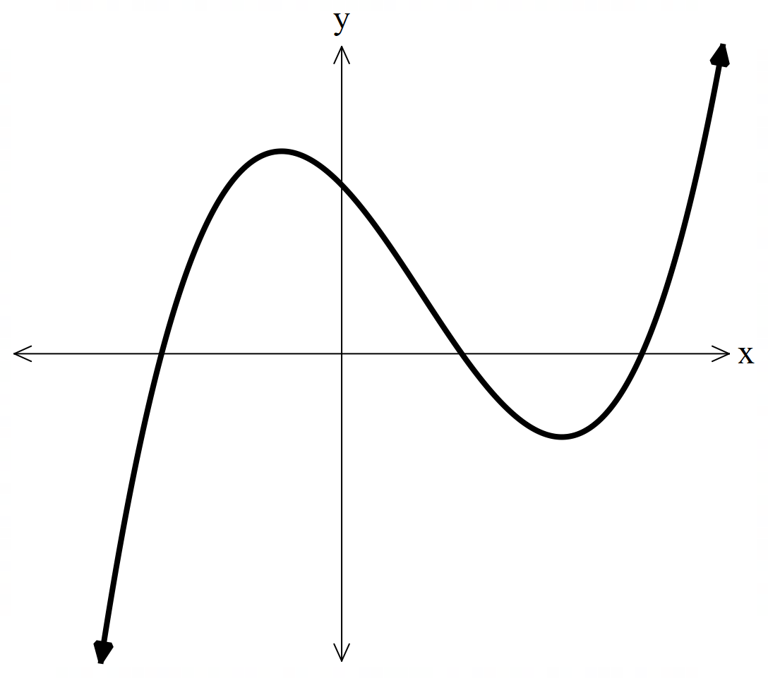

1. Sketch below a graph of the first derivative of . Label on this new graph stationary points.

|  |
| --- |
| **c** |
|  |
| **Specific behaviours** |
| 🗸 correct shape  🗸 correct positions of x intercepts on new graph  🗸 labels nature of x intercepts on new graph (accept old graph) |

1. Sketch below a graph of the second derivative of . Label on this new graph any inflection points

|  |
| --- |
| **c** |
|  |
| **Specific behaviours** |
| 🗸 correct shape (need not be exact line- but close to it)  🗸 correct position of x intercepts on new graph (accept old graph)  🗸 labels inflection pt |

Q5 (4 marks)

The cost  for the production of  thousand units of a certain product is given by

 , .

Determine the value of for which the **average cost per unit** is a minimum and find this minimum average cost. Justify. (No need to simplify)

|  |
| --- |
| **c** |
|  |
| **Specific behaviours** |
| 🗸 divides cost by x  🗸 uses quotient rule  🗸 solves for stationary point  🗸 states min av cost, un simplified (no need for units)  NOTE max of 1 mark if quotient not used (i.e average cost) |

Q6 (4 marks)

Consider a train moving in a straight line. The displacement,  km, from its starting position at time  minutes is given by  , . The train changes direction twice. Determine the distance in km between these two positions on the track.

|  |
| --- |
| **c** |
|  |
| **Specific behaviours** |
| 🗸 determines velocity function and equates to zero  🗸 solves for x for one rest stop  🗸 solves for x for second stop and then subtracts the two  🗸 simplifies the distance between and gives units |